# REST API (Hands On)

REST API Documentation link

<https://docs.databricks.com/api/workspace/introduction>

* Here, we are going to explore how to use REST API to programmatically interact with your Databricks workspace.
* Here we have the latest version of each API. Let us take a look on the jobs API.

**Jobs API version 2.0**

<https://docs.databricks.com/dev-tools/api/latest> (OR)

<https://docs.databricks.com/aws/en/reference/api>

**Jobs API version 2.1**

<https://docs.databricks.com/api/workspace/jobs_21>

* The jobs API allows you to programmatically **create, edit** and **delete jobs**.
* To authenticate to Databricks API, you need to use a Bearer token.
* Let us switch to our Databricks **workspace** to see how to generate a personal access token. In your Databricks workspace, click on your Databricks username in the top bar and choose **User Settings** from the menu.

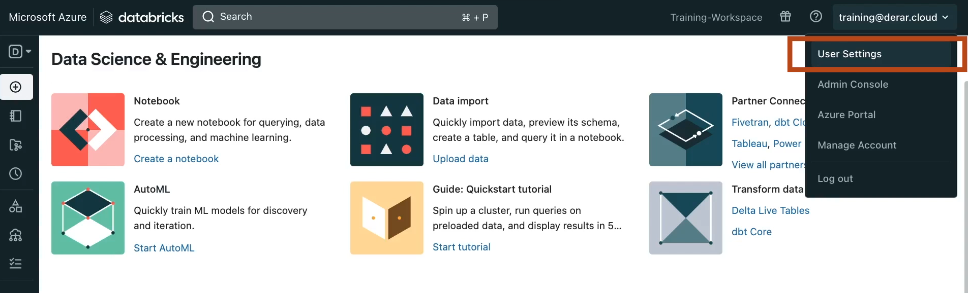

* Under the "Access tokens" tab, click "Generate new token". Optionally type a comment that helps you identifying this token in the future. For example, token for REST API. Next, set the tokens lifetime and click generate. Let us copy the display token now since we will not be able to see it again. And click Done.

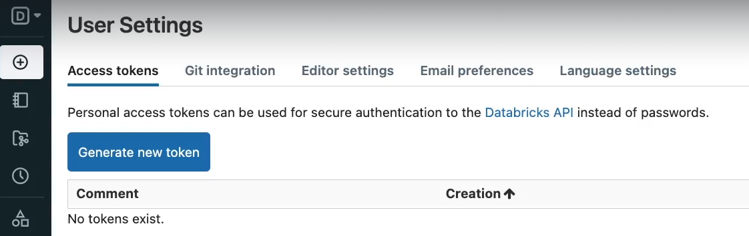

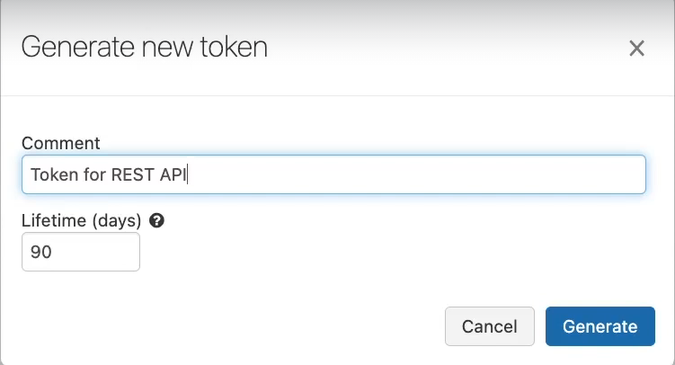

* For this demo, we are going to use **Postman** but you can use any of the API tool. In Postman, click the (+) sign to open a new request tab. Under **Authorization**, select Bearer Token. And paste here your databricks personal access token you have just copied.

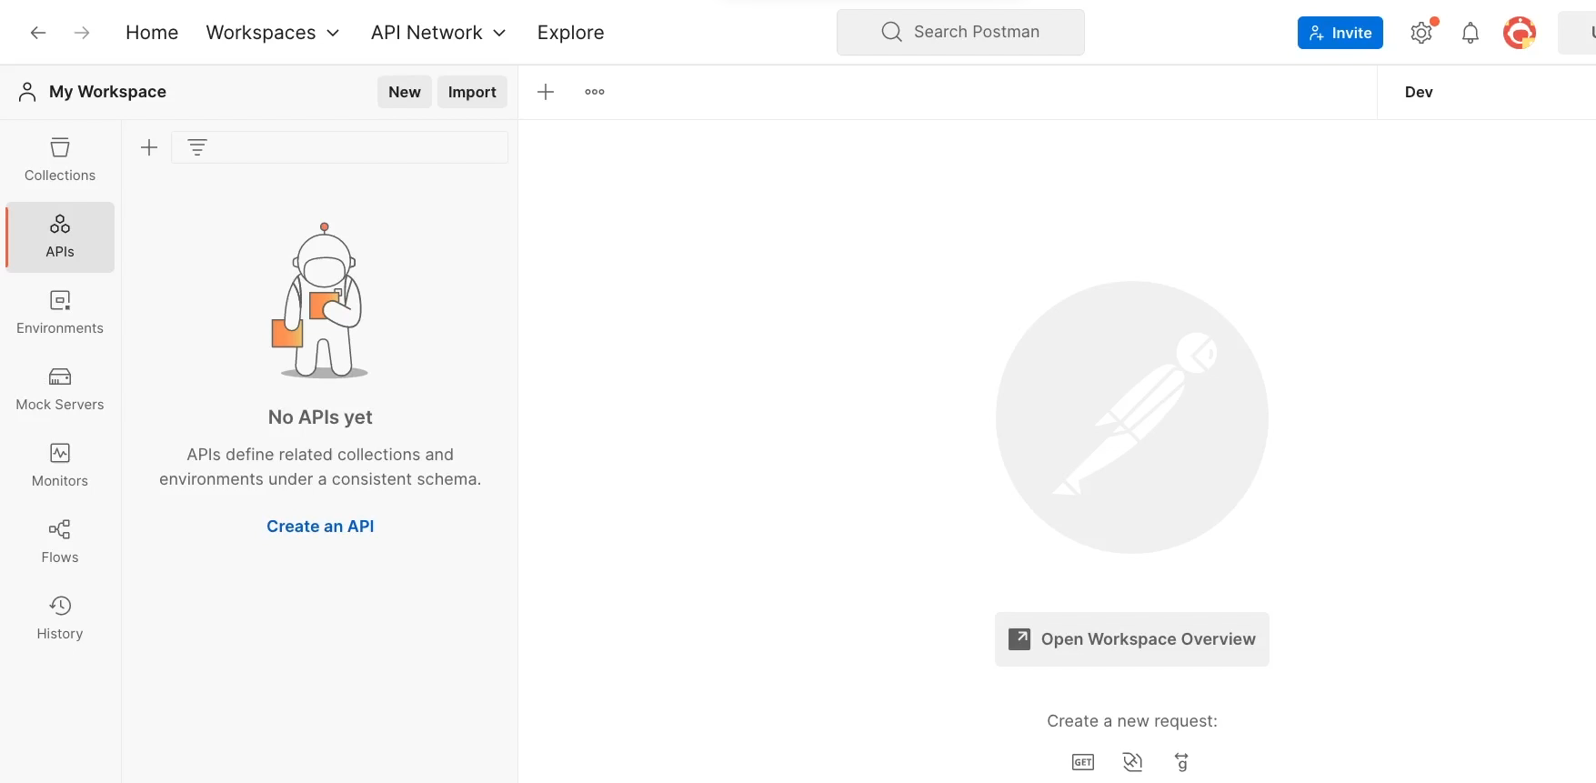

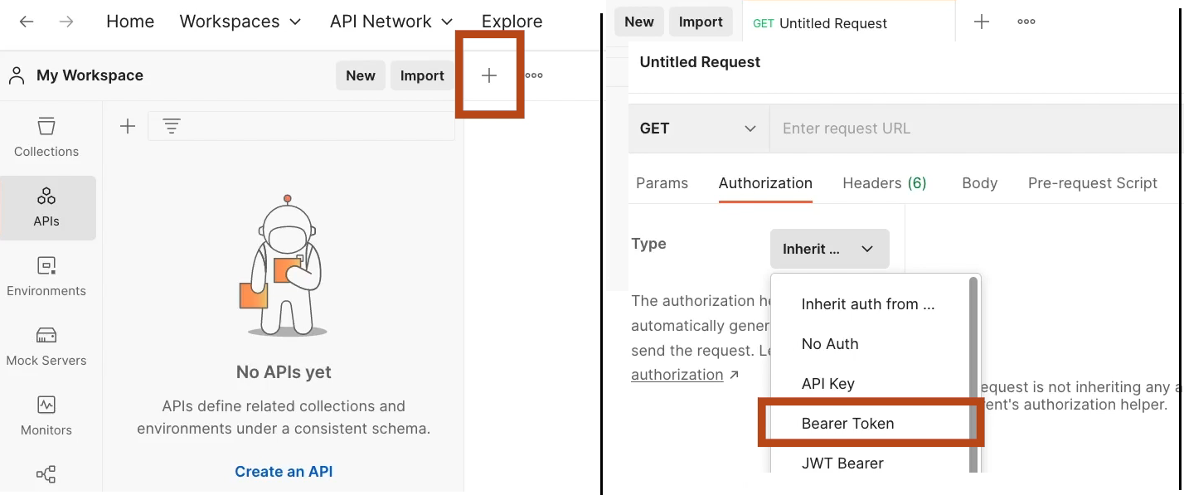

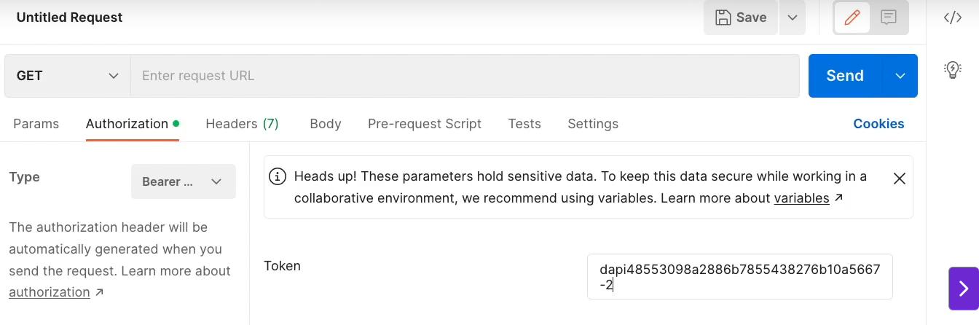

* Let us now switch back to the **Jobs API reference** page. If you click this button, you will see the full list of the job’s APIs. Let us expand the first one (i.e. Create a new job) to explore the API for creating a new job.

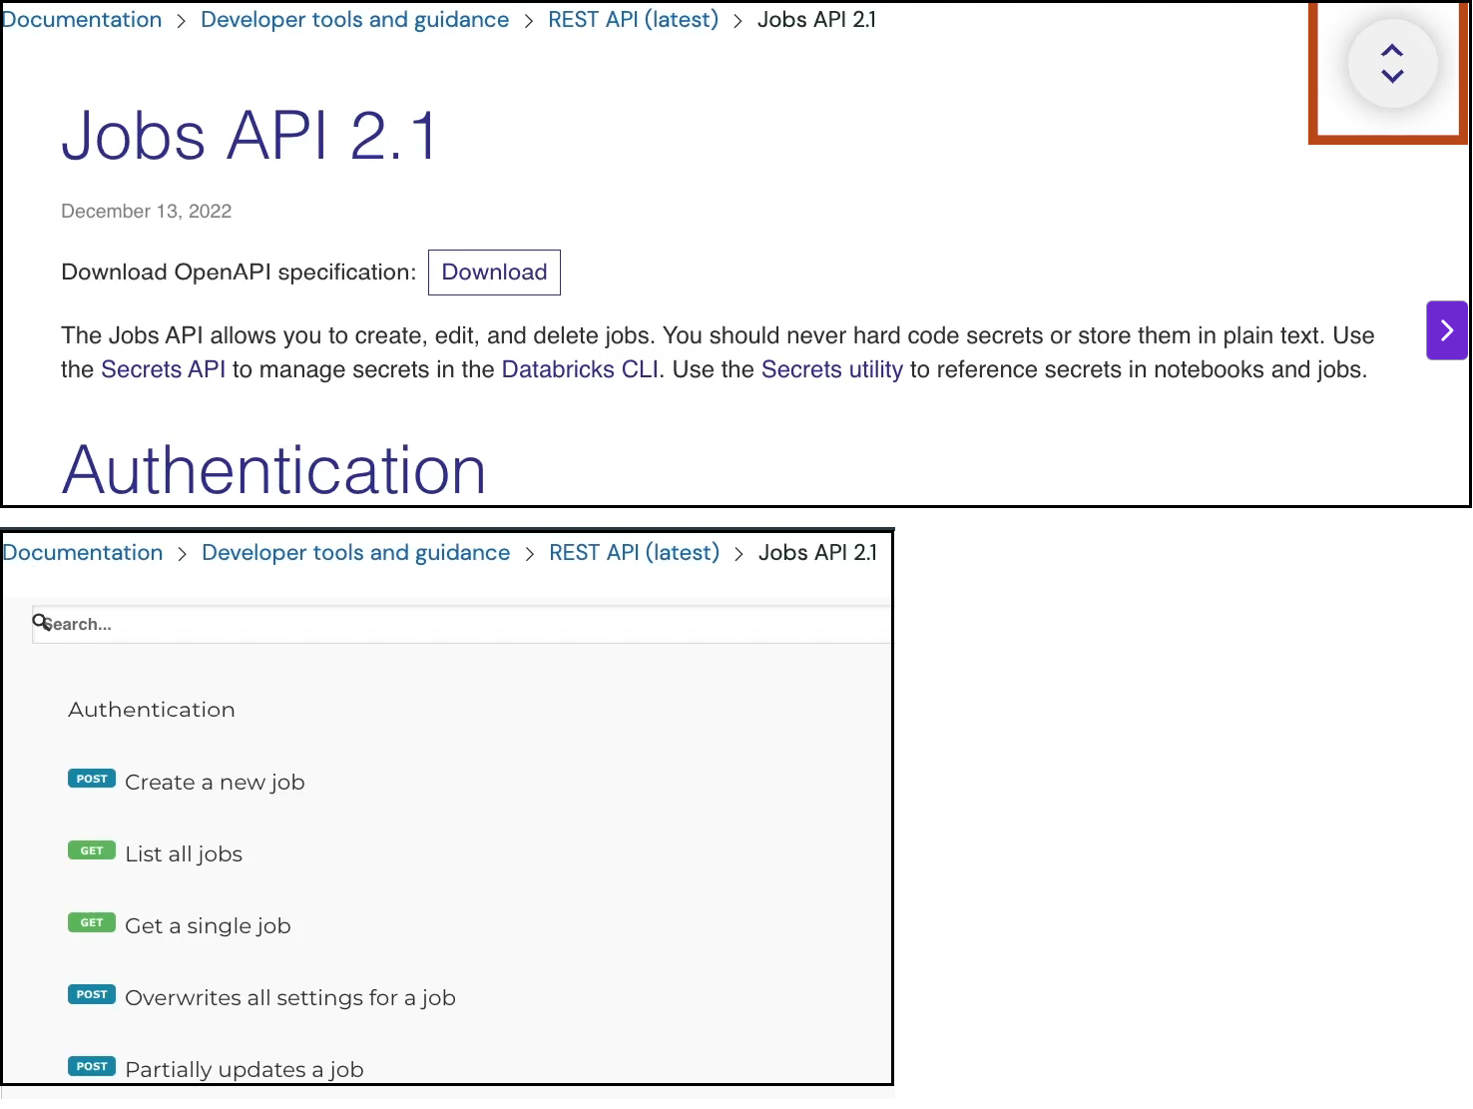

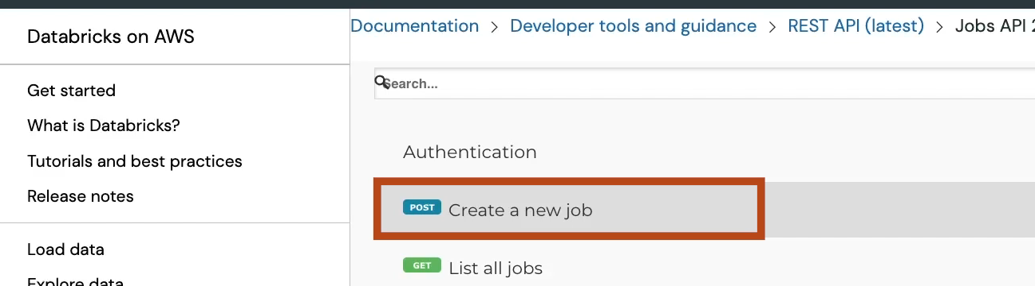

* Here we see the schema of the request body that need to be sent as a **Post request to this endpoint**, and you have also a **request sample** in JSON format.

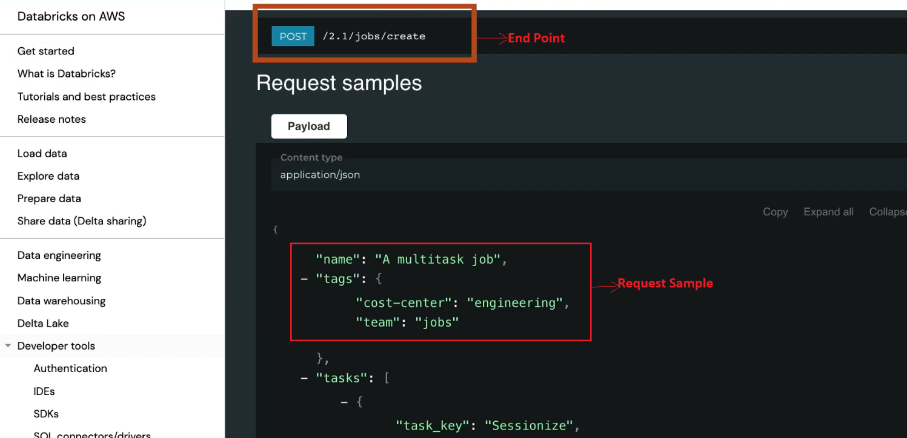

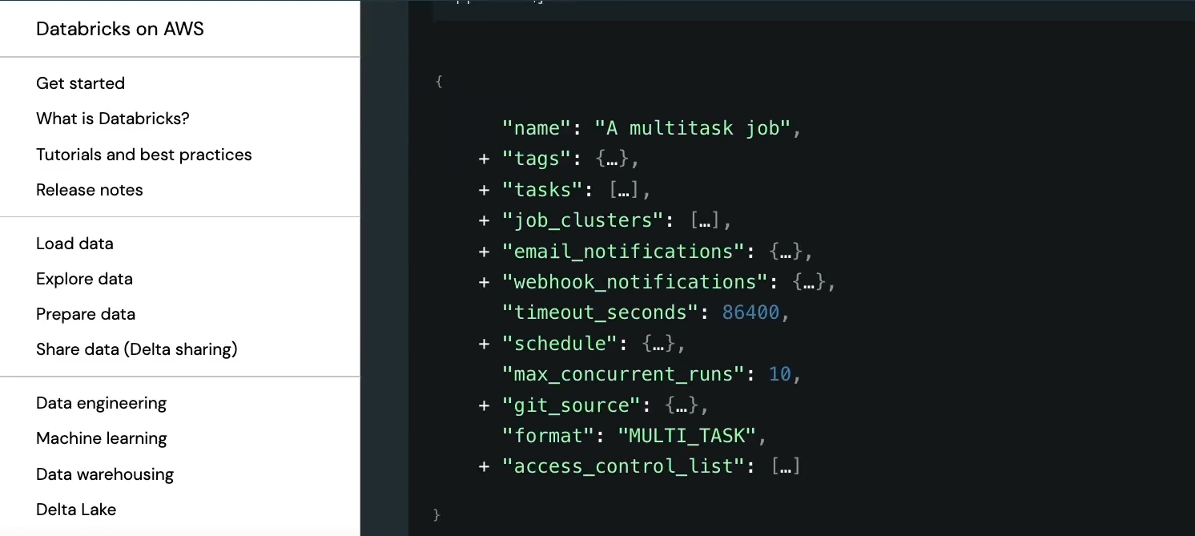

* And below are the **response samples**.

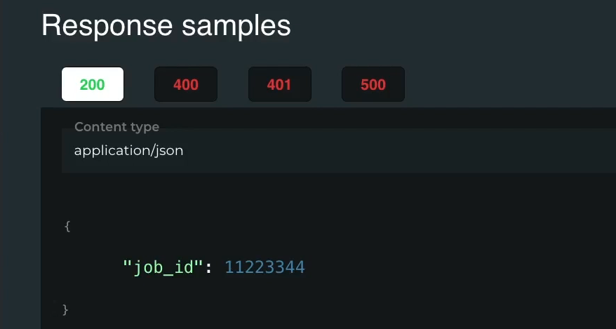

* The **request URL** is preceded by the domain name of your workspace slash(/) api.

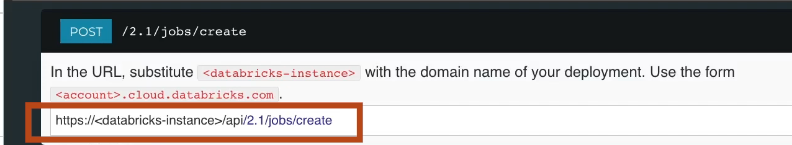

* Let us copy this URL and come back to Postman. Select Post request from here and paste the request URL here.

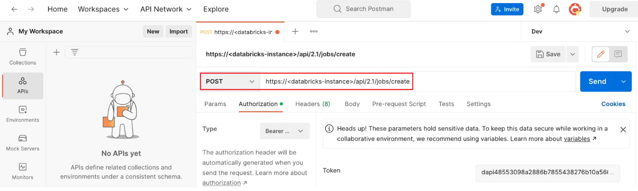

* To get your Databricks instance name. Go to your Databricks workspace and copy the domain name from the URL.

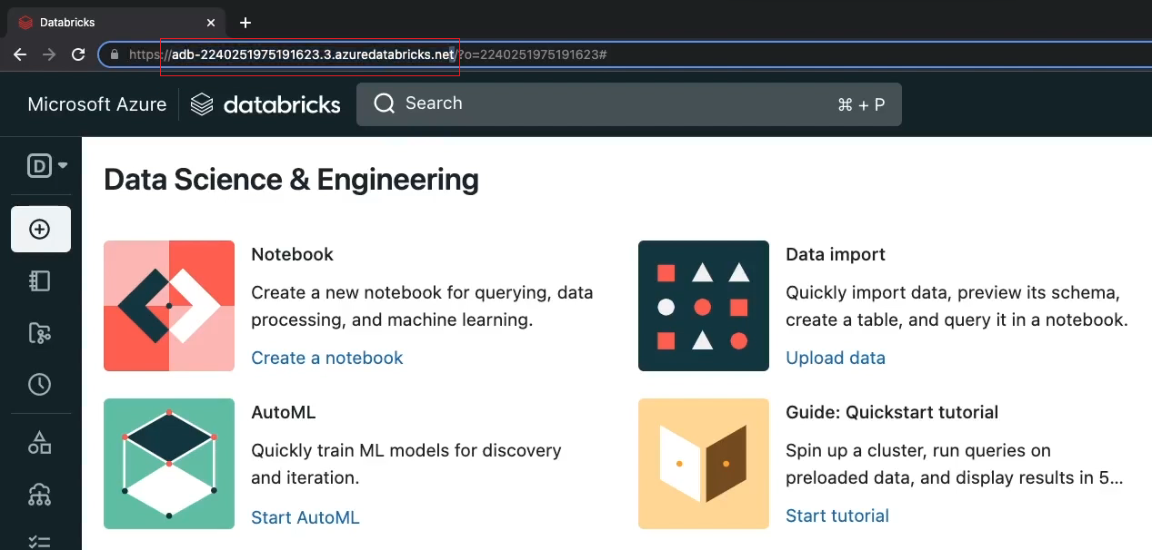

* Now replace the Databricks instance by the domain name you have just copied.

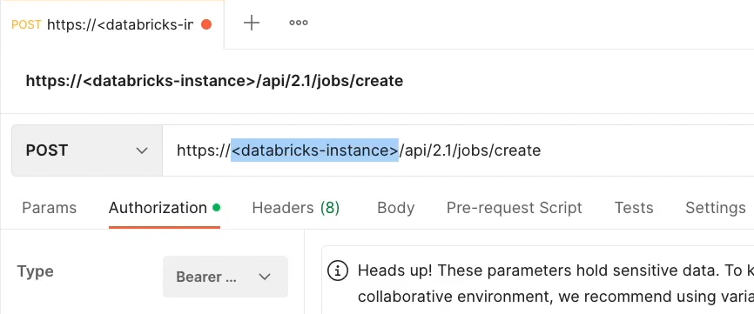

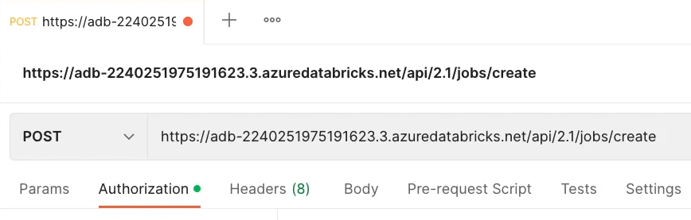

* Lastly, we need the JSON definition of our new job. For this demo, we are going to use the same definition of our **bookstore job**.
* Let us switch to our Databricks workspace to get the job definition. In our bookstore jobs page, click on the three vertical points. And select **view JSON**.

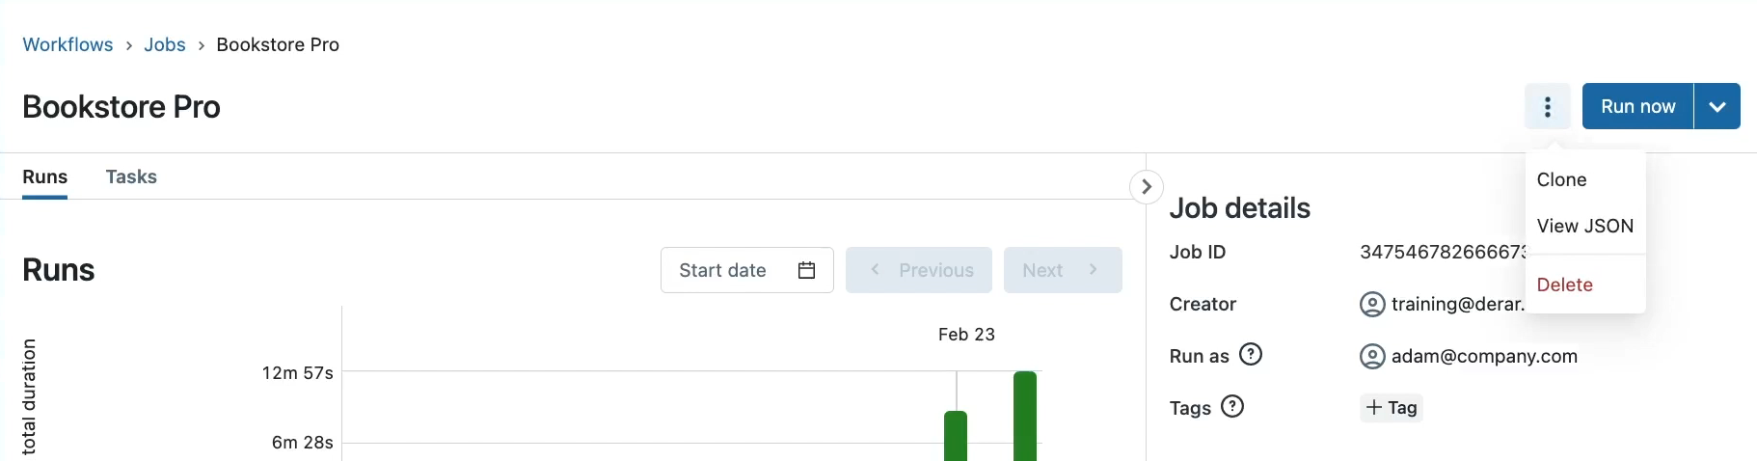

* Under Create tab. You see the full definition of our job in JSON format. Let us copy this JSON definition and come back to Postman.

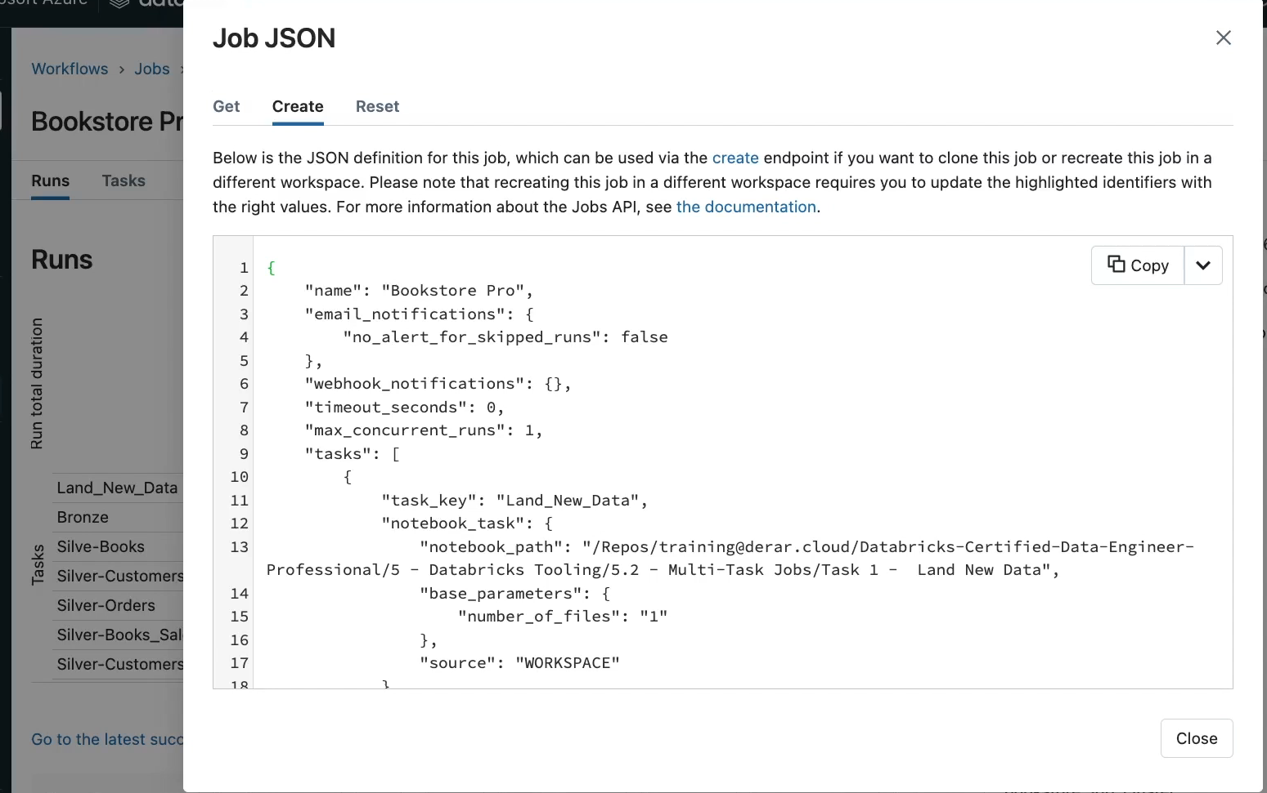

* In Postman on their **Body** tab. Select “**raw**” format. And paste here the JSON definition. And let us change this to JSON format. The name element shows the name of the job. Let us **rename this new job** to distinguish it from our existing job. And of course, from here you can change any other configuration if needed. For now, let us keep it as it is and click **Send**.

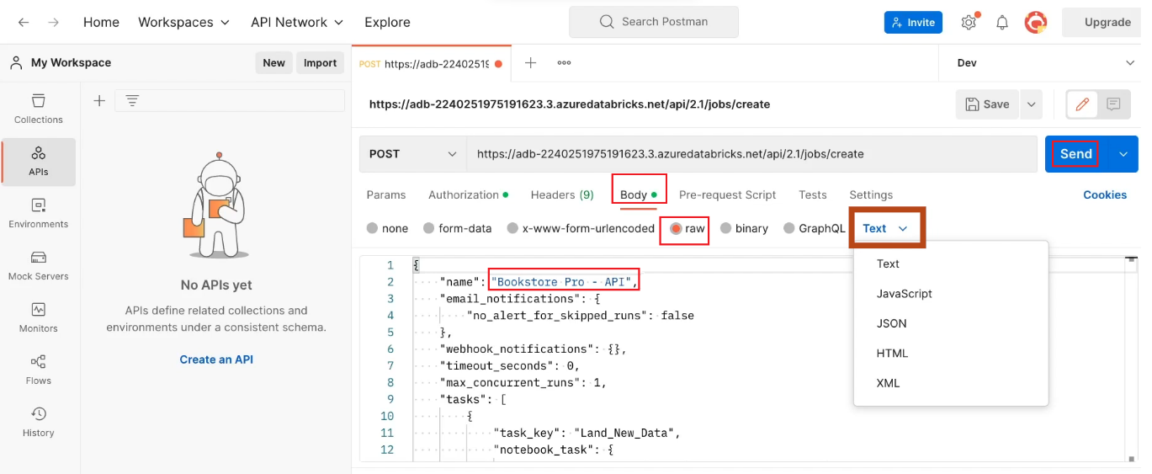

* The job has been successfully created with 200 status, and we see here the response data.

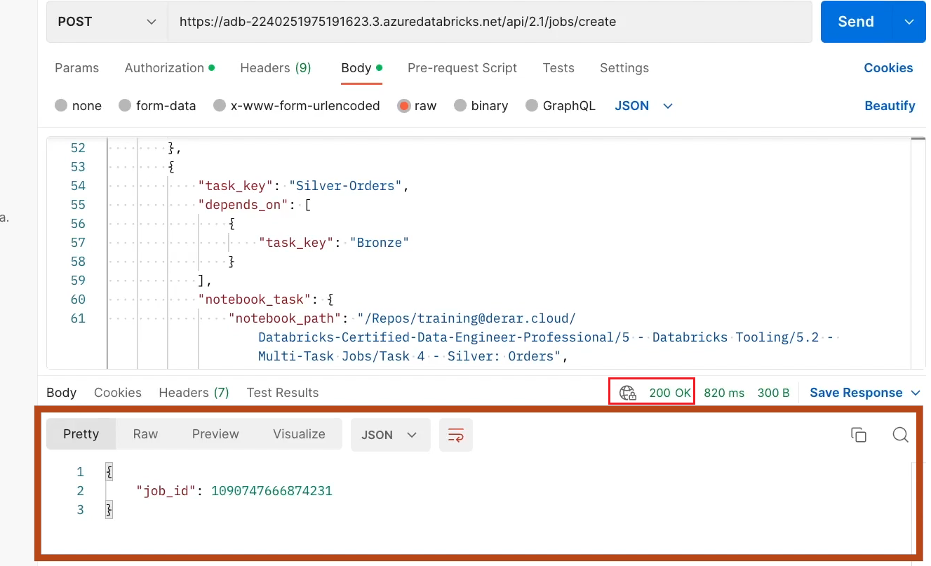

* As you can see, Create Job API returns the ID of the newly created job. We need this job when sending other requests, like, for example, for running this job.
* Let us confirm that the job has been created in our Databricks workspace. Here is our **bookstore job** created via **Databricks API**. And in the right sidebar you see the same job ID that we have received in the API response.

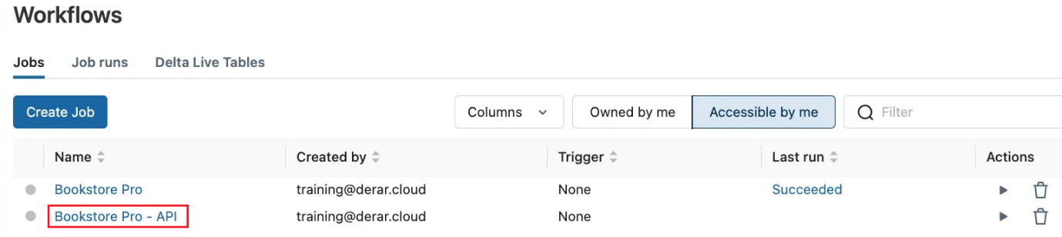

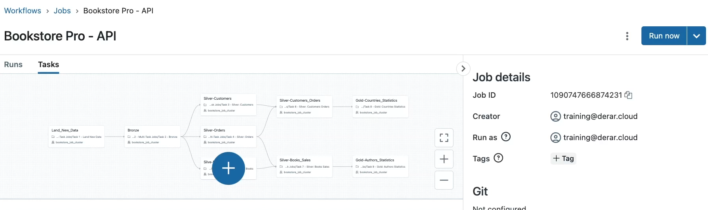

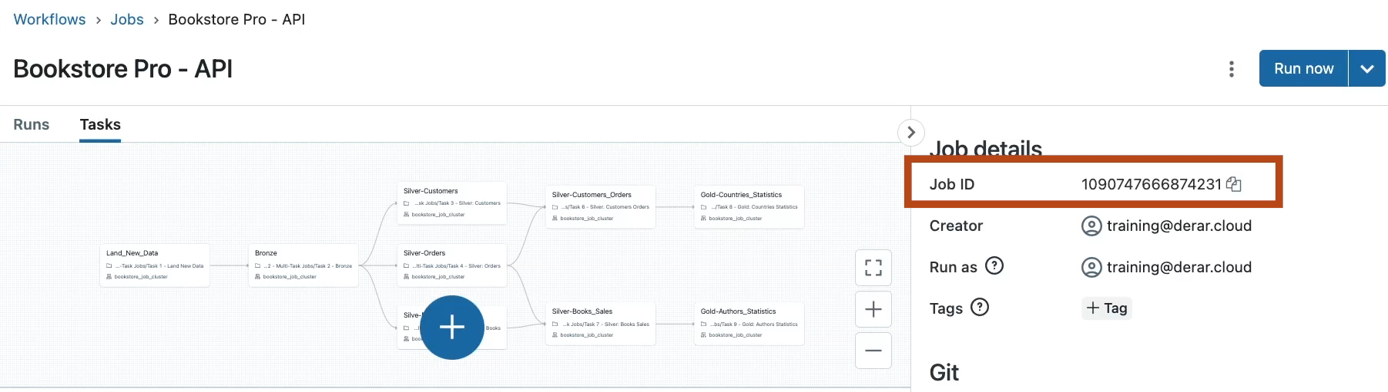

* But what happens if we resend the same request multiple times? In Postman, Re-click the **Send** button to try this. Here we see a new job ID. Let us switch to our Databricks workspace to see this.

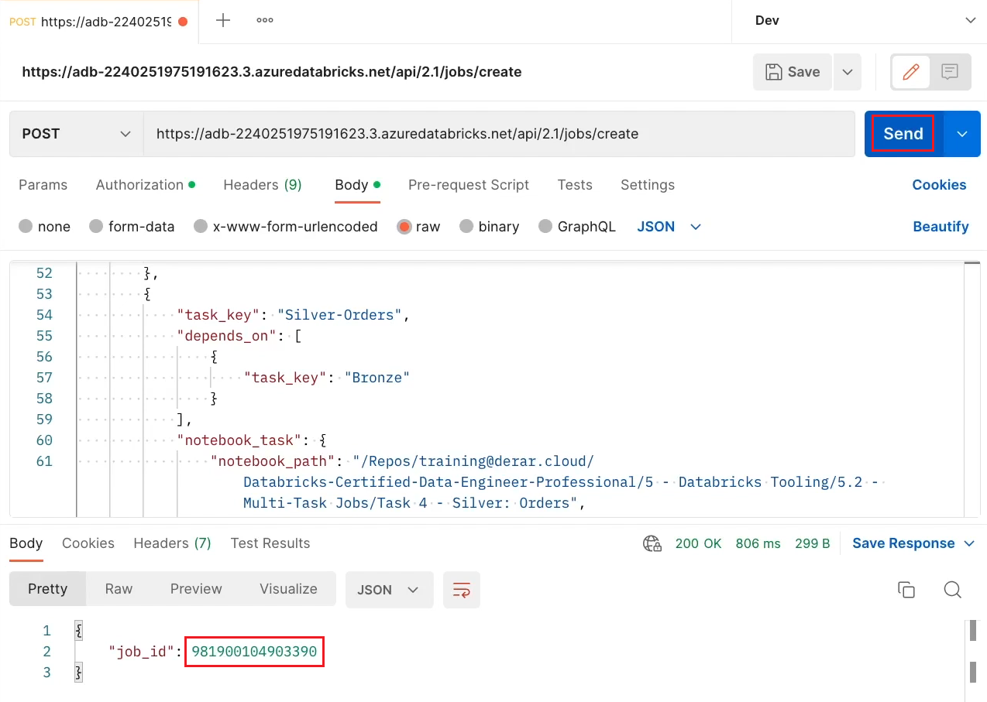

* As you can see now, we have two jobs named Bookstore Pro API. But of course, with different job ID.

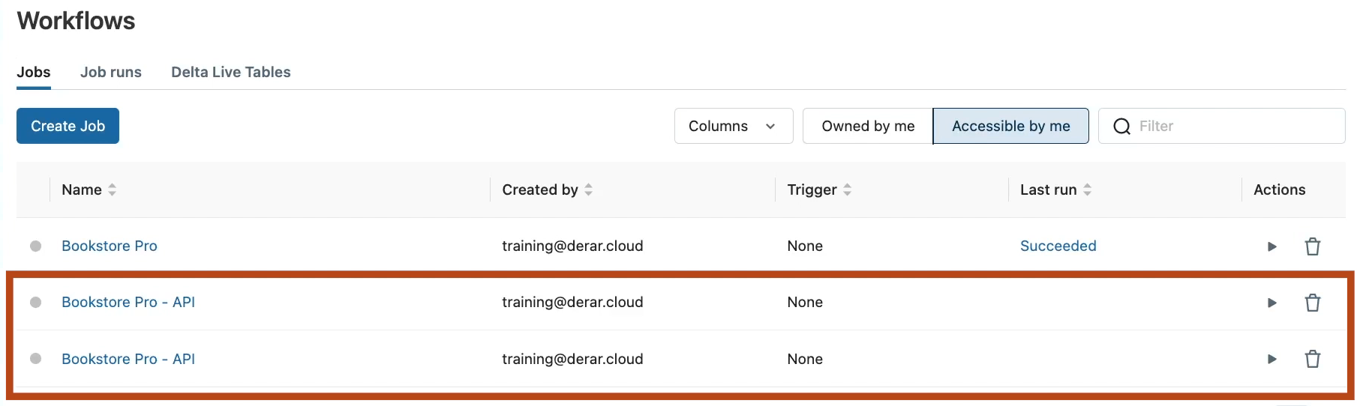

* Let us now see how to run a job via API. From the Jobs reference page, we see the API for triggering a new job run.

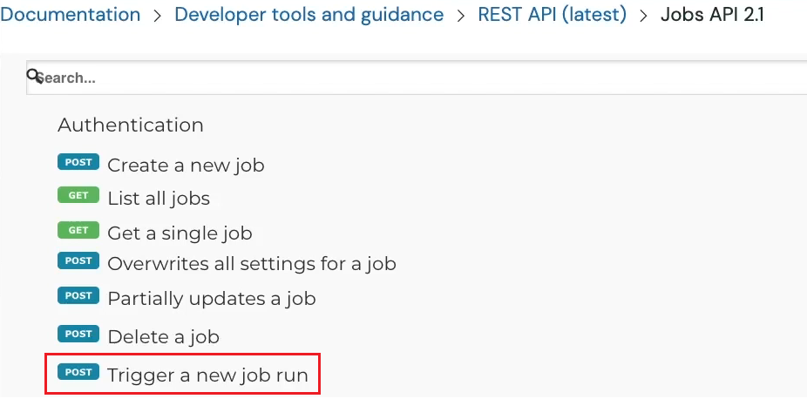

* For this, we need to send a **Post request to the endpoint jobs / run-now**. And mainly provide the ID of the job to be executed. Let us run this in Postman.

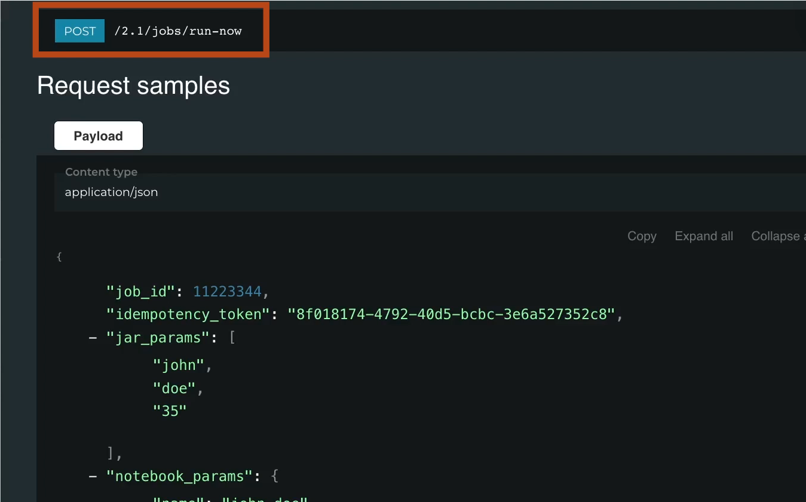

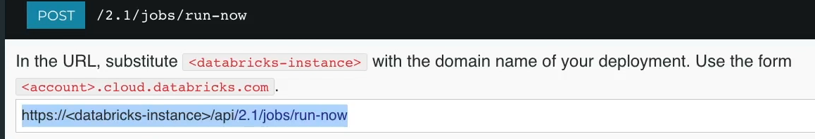

* Create a **new Post request**.

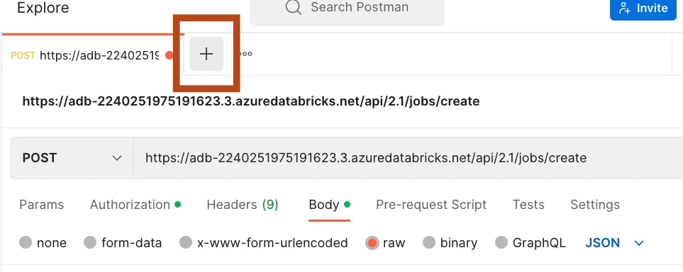

* Set the **Bearer token** in the **Authorization** tab.

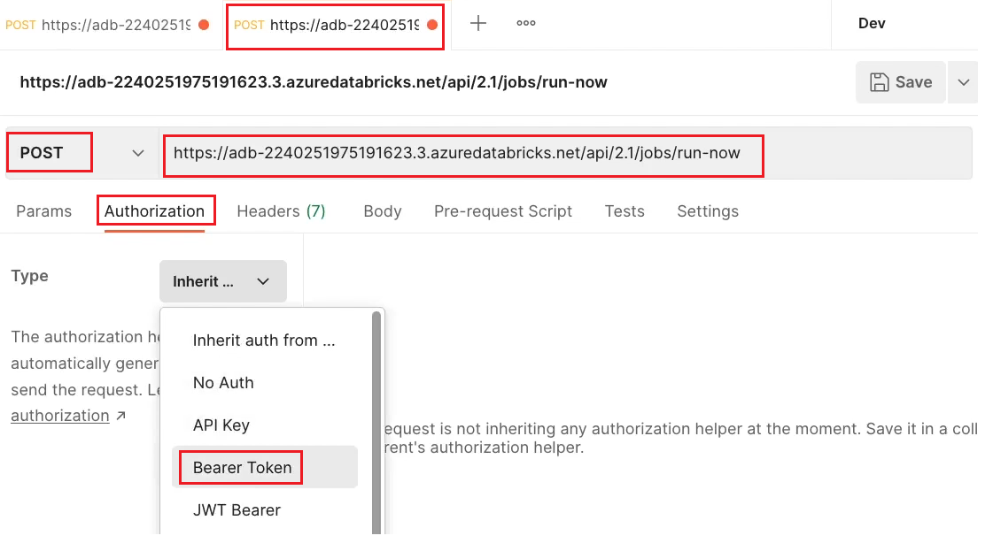

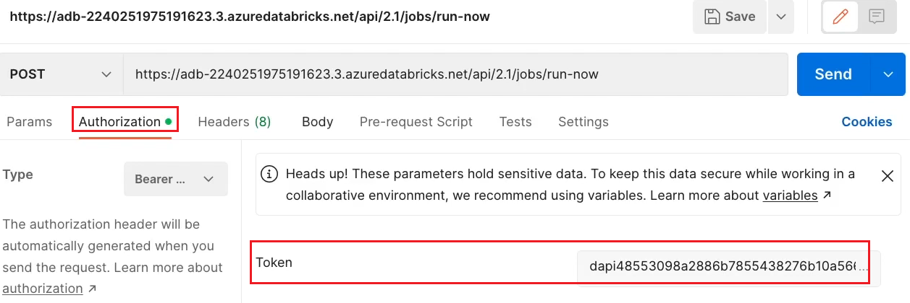

* And in the **request body** provide the job ID of our last created job. Now click **Send**.

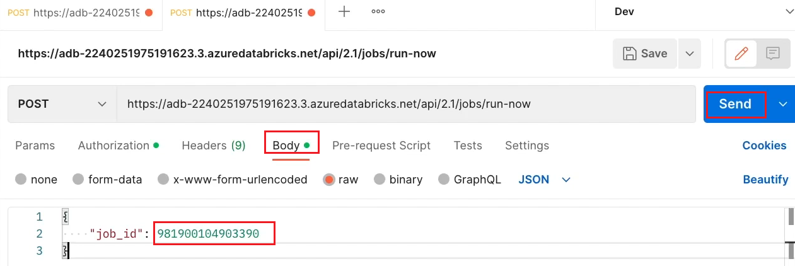

* A **new run** has been triggered for this job. And we got here the ID of this triggered run. This is a globally unique ID that we can use to cancel this run or to get its status, for example.

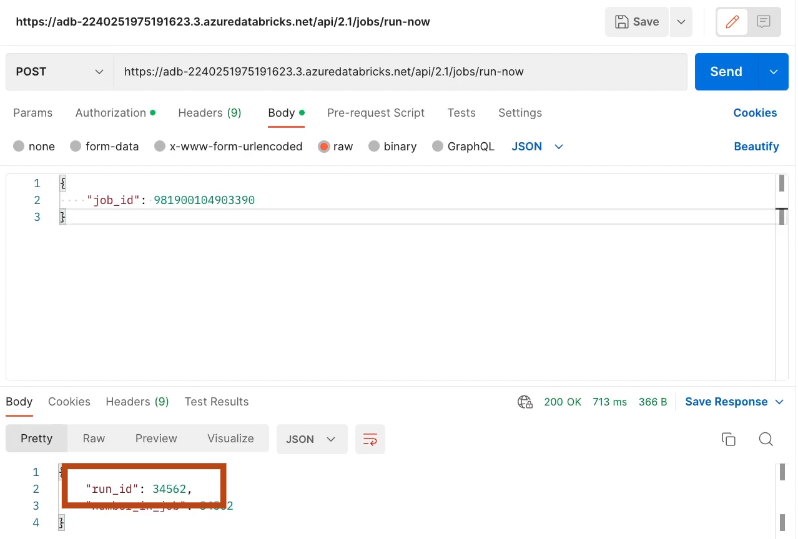

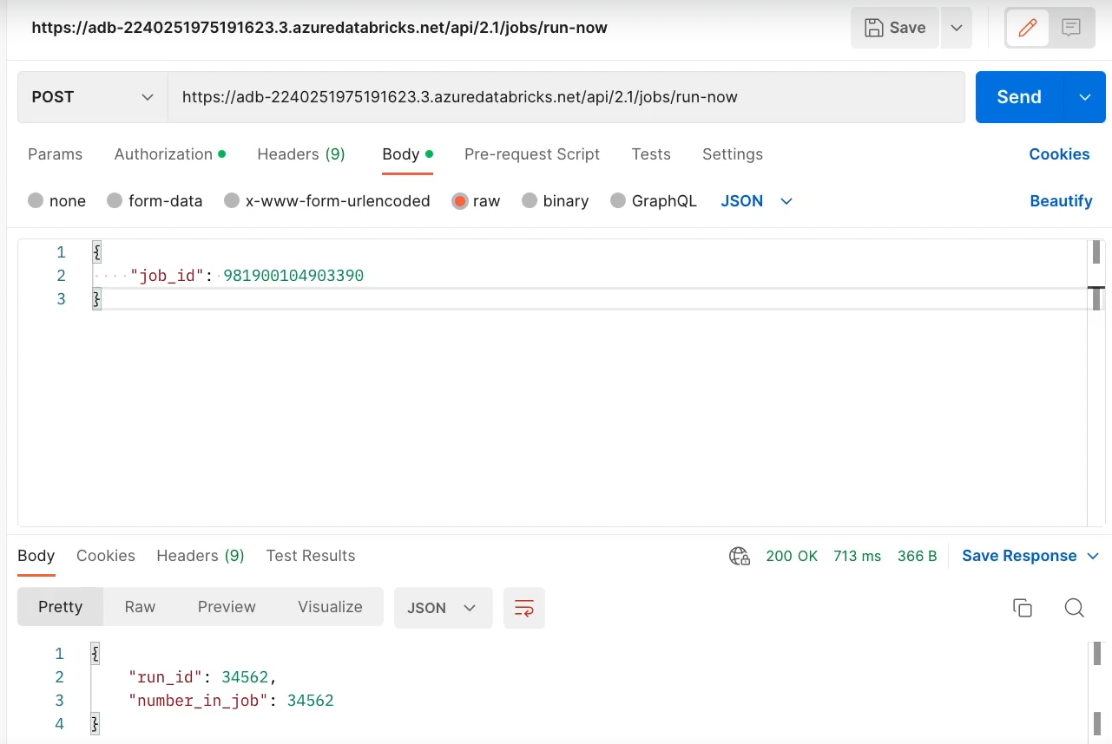

* Let us now check this job run in our Databricks workspace. Here we see the run triggered via the API.

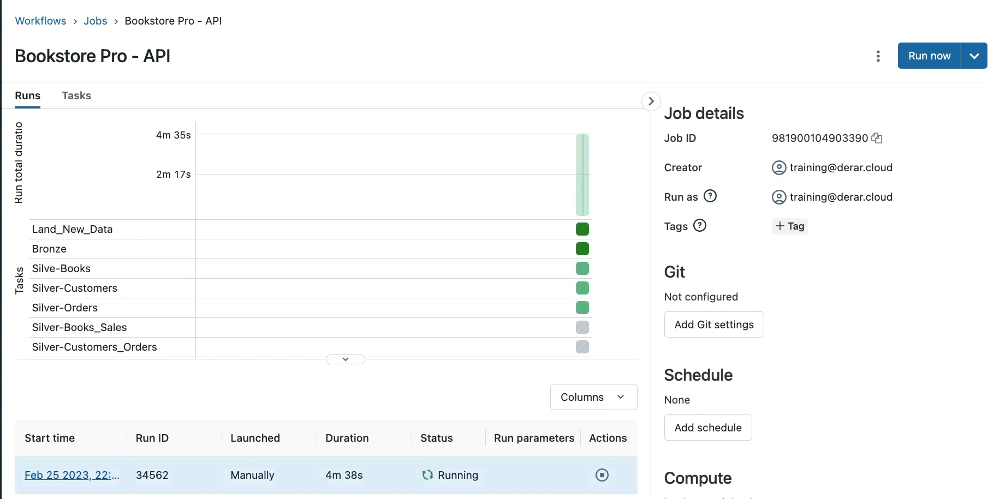

* If you open this run. You can see its run ID in the right-side panel.

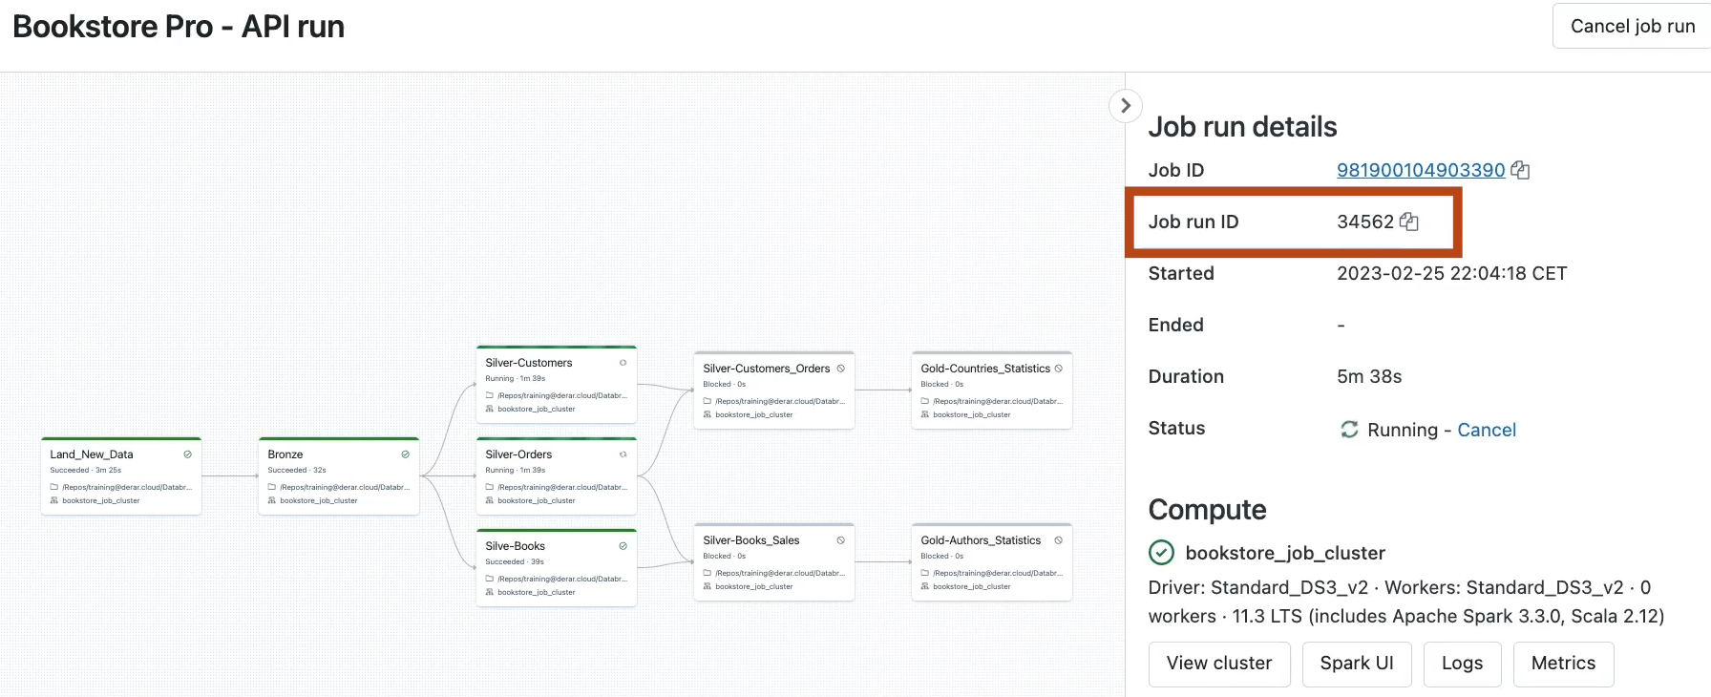

* Let us see how to get the status of this run via API. From the jobs API reference page. We can see the API to get a single job run. Let us expand this.

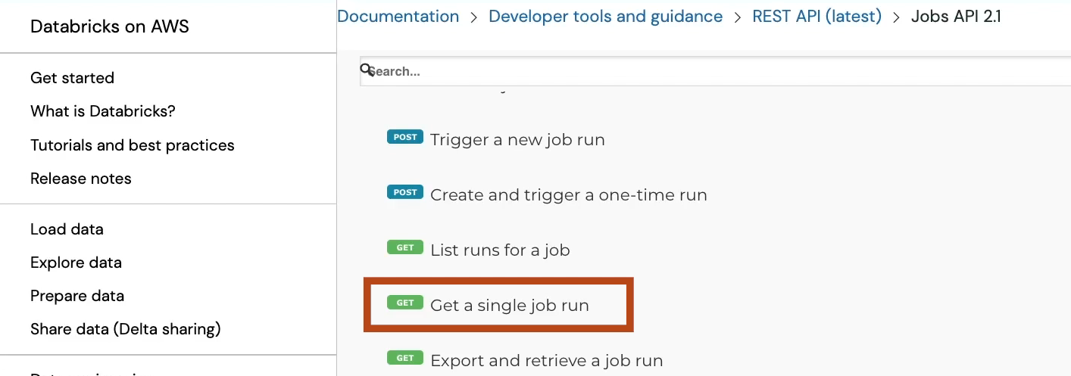

* Notice here that in this case we need to send a Get request to this endpoint instead of Post request. Let us copy the URL and run this in Postman.

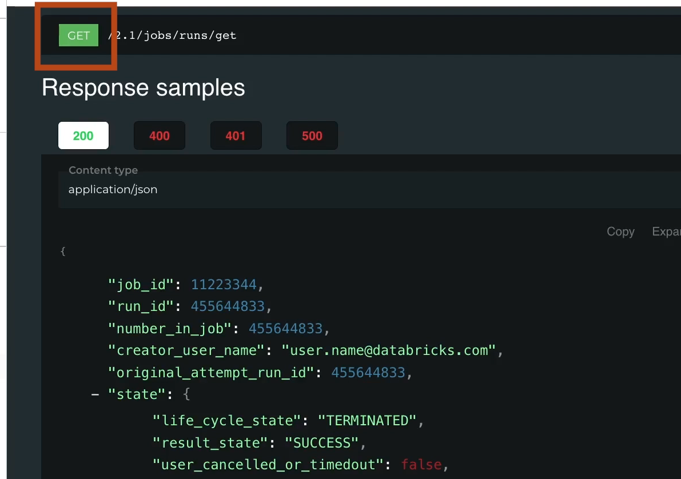

* From here, choose **Get** request and in the body p**rovide the run ID**. Now click **Send**.

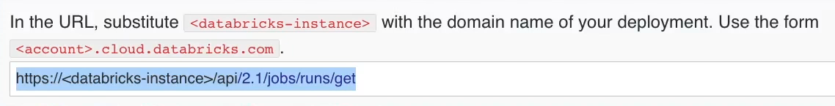

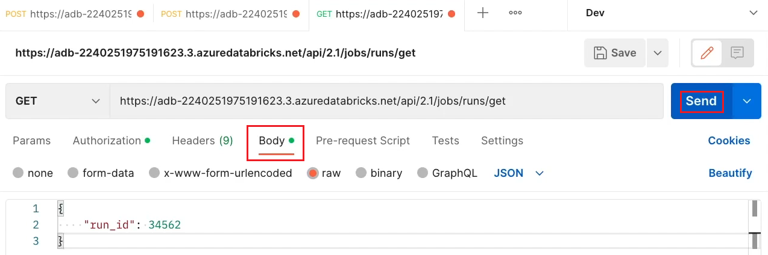

* Here we see the current status of this run. As you can see, it is currently running. Notice here that in addition to the run ID of our triggered run.

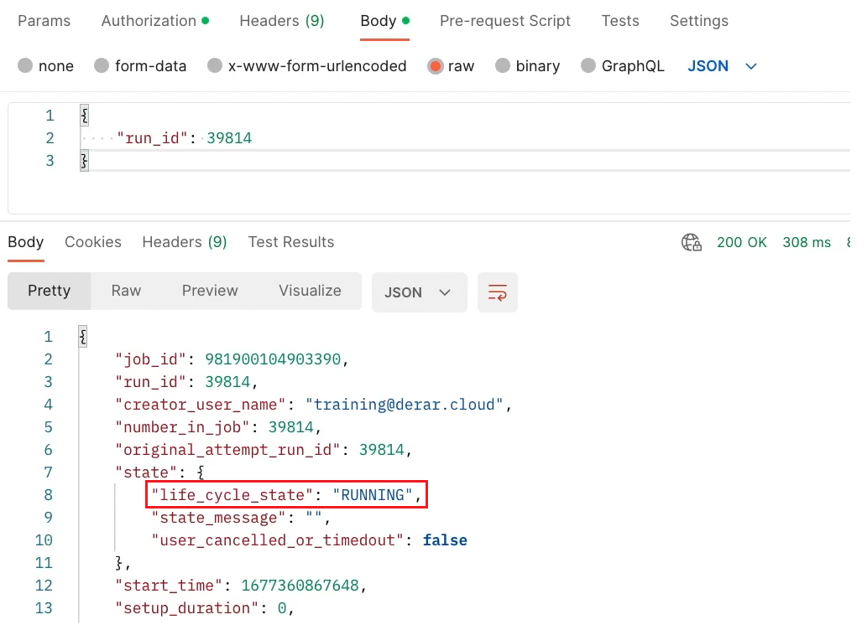

* Each task in the job has its own unique run ID as well. For example, here is the run ID of our Land New Data task.

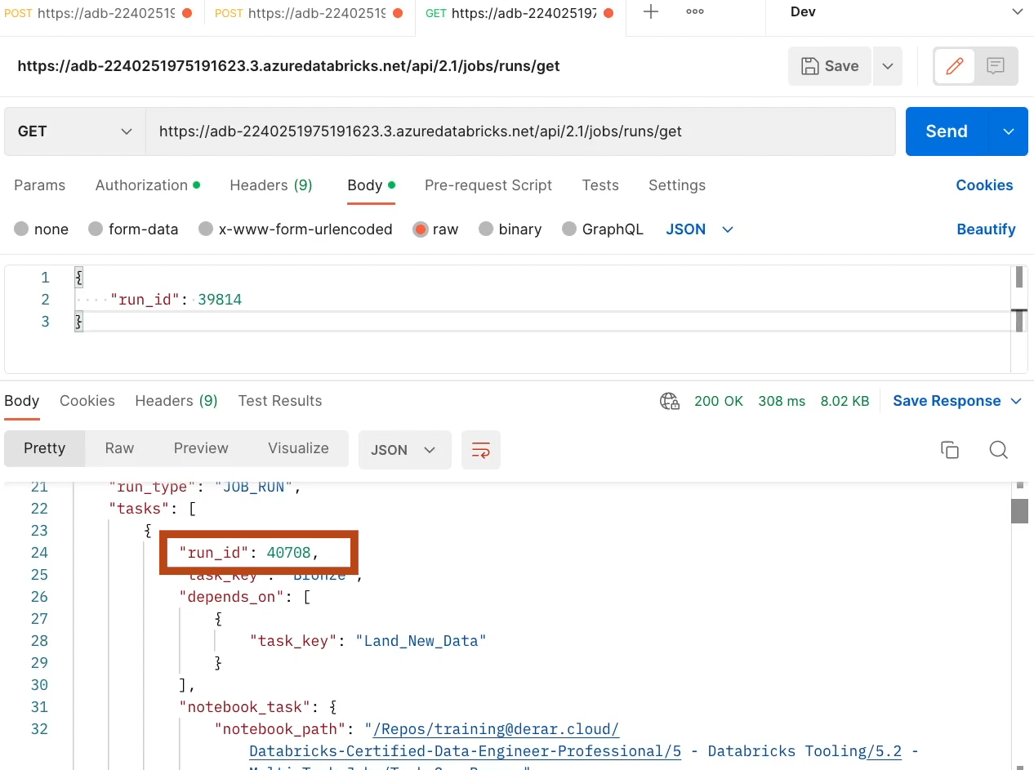

* While we see different run ID for the bronze task. The job run must have finished by now. **Let us resend the same request to get the updated status**. Click the **Send** button. Here we see the lifecycle status TERMINATED instead of RUNNING.

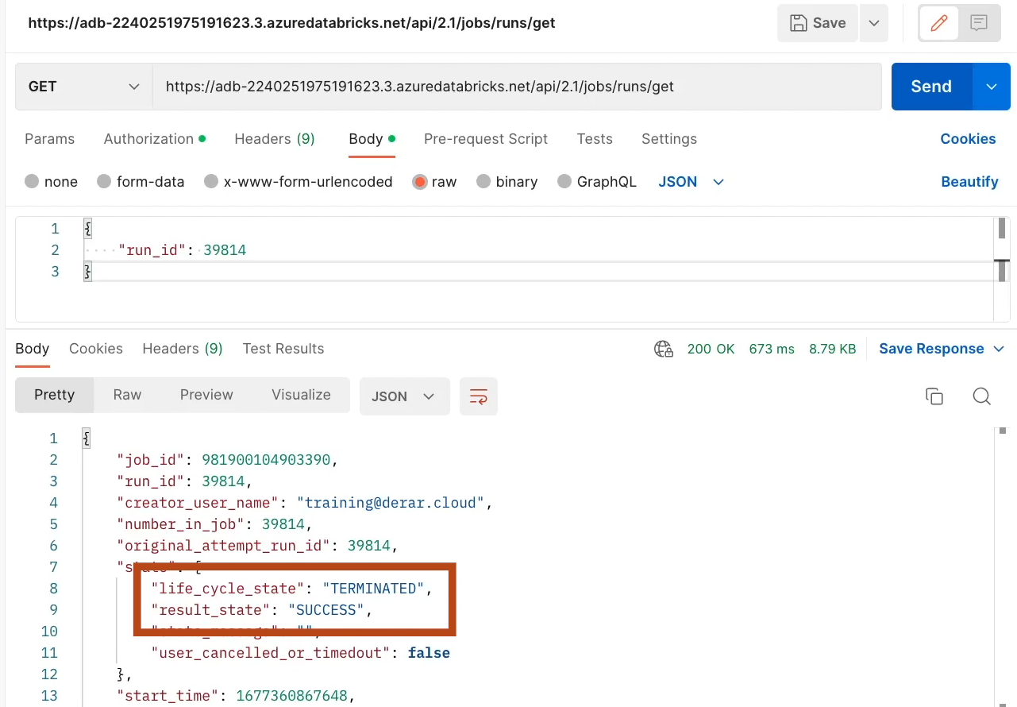

* And we see the result status SUCCESS, indicating that the job run has been successfully terminated.

# DATABRICKS API (Hands On)

Databricks CLI Documentation link

<https://docs.databricks.com/dev-tools/cli>

Here, we are going to work with Databricks **Command Line Interface or CLI**.

* To use Databricks CLI, you need to have Python installed on your machine.
* For this demo we will work on Windows CMD
* Open the start menu in Windows and search for CMD. And click Command Prompt.
* Begin by installing the Databricks using PIP.



* Now we need to configure the connection to our Databricks workspace.
* For this. Let us run this command:
* **databricks configure –token**

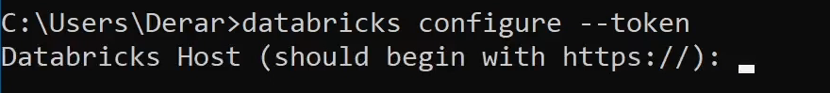

* Copy the workspace URL with the HTTP protocol.

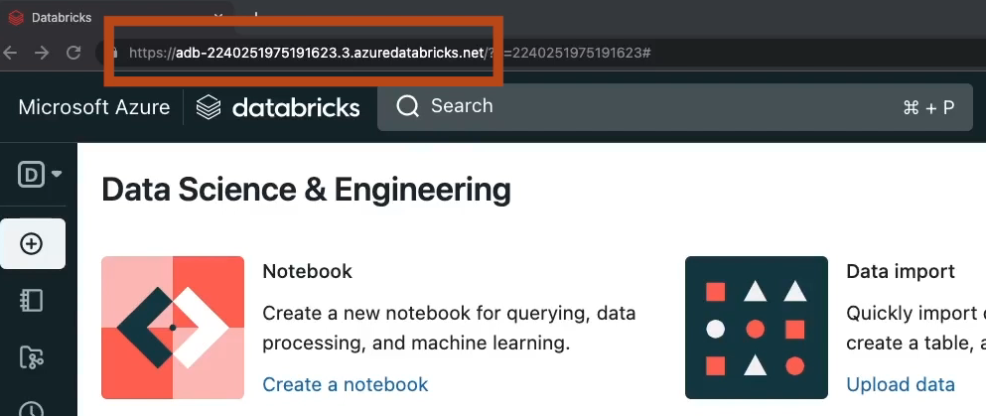

* And paste it here.
* Next, enter your personal access token generated in the last lecture or you can generate a new one. **Important note:** On Windows use right click to paste the token string in the cmd. This will paste the string automatically. Now hit Enter.

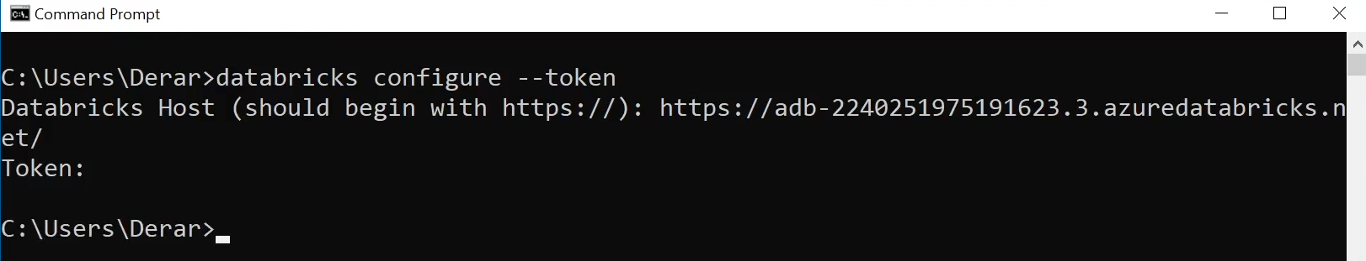

* You can see your configurations by navigating to your username folder. Here, Look at the databricks config file. And open it with a Notepad. As you can see in this file, you have the workspace URL, and your token in plain text. Let us close this.

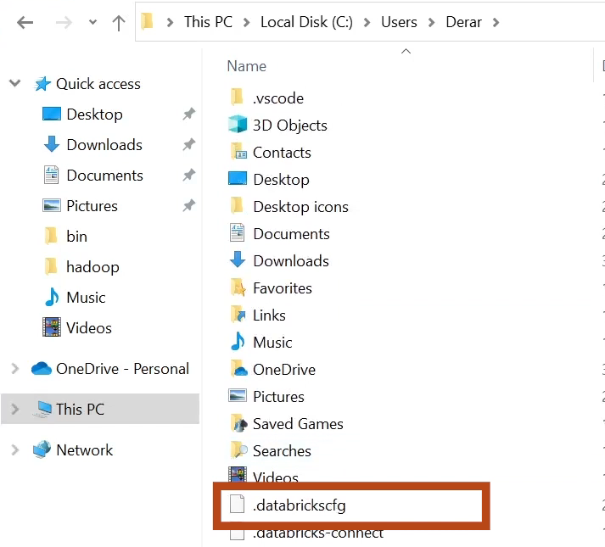

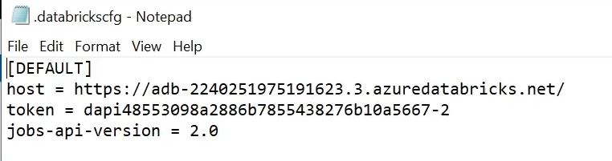

* So now with this configuration, we have access to our Databricks workspace from the CLI.
* To see the list of options run the help command: **databricks -h**



* Similar to Databricks API, The CLI allows you to manage various Databricks resources like jobs and clusters. In fact, the CLI is built on top of the Databricks REST API. Let us see what options we have to work with the clusters.

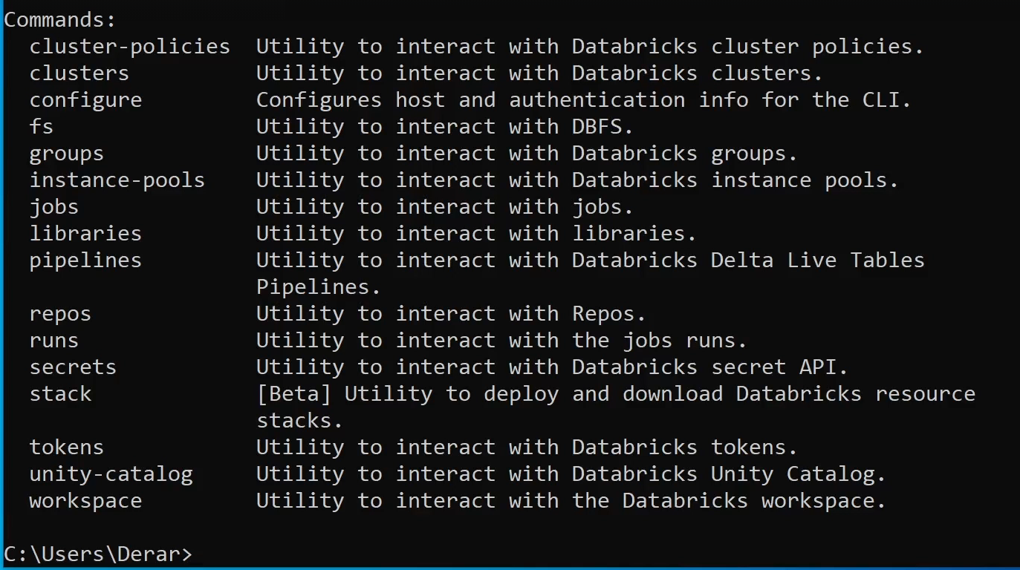

* You can view all the clusters in your Databricks workspace by running clusters list command. As you can see, this shows both all-purpose clusters and also job clusters.

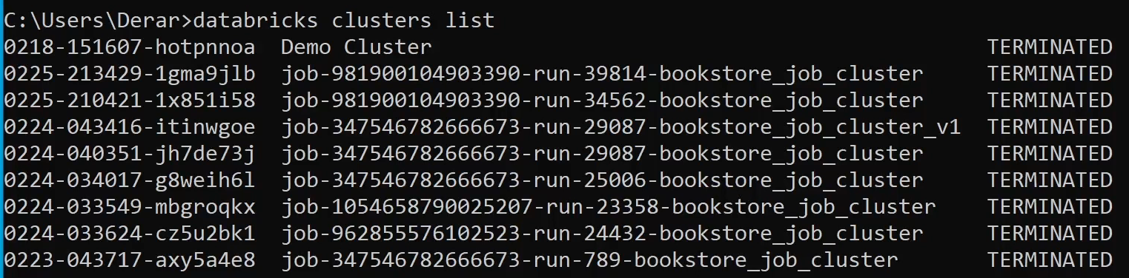

* Let us start our Demo Cluster using its ID. The cluster now must have started.

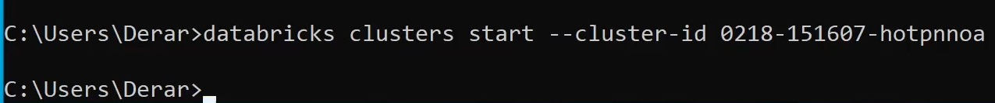

* Let us switch to our Databricks workspace to confirm this. The cluster is running now.

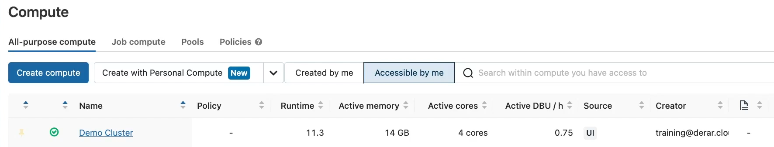

* Let us check its status from the CLI. If you run again the cluster's list command. You see that our Demo Cluster is currently running.

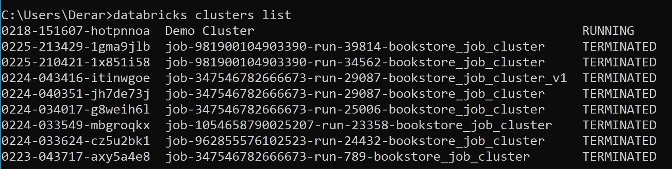

* Let us now see how to work with DBFS from the CLI. To interact with DBFS, we use the **fs** command. As you can see, you have commands like **cp** for copying files, **ls** for listing files, and **rm** for removing files. However, cp is particularly interesting because it's not only used for copying files within DBFS, but it can be also used to copy files from your local file system to DBFS and vice versa.
* Let us try to upload a JSON file from our local file system to DBFS. Our local file is located in the C drive in a folder called data, and we will use the mode overwrite in case the file is already in DBFS in this location.



* **Let us confirm that the file has been successfully uploaded**.In a notebook, if we list the files in our target directory. We can see that our file has been indeed uploaded to DBFS.

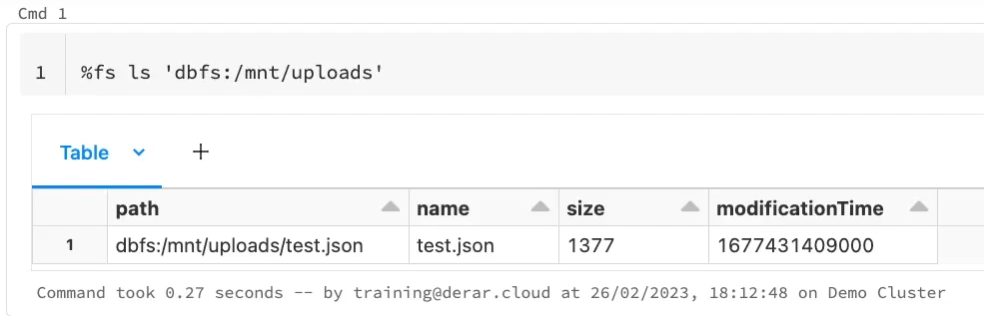

* Let us see another useful command in databricks CLI, which is the secrets command that allows you to interact with Databricks Secrets. Similar to Azure Key Vault or AWS KMS, **Databricks Secrets** is a key-value store that allows you to protect your credentials. Secrets are organized in groups or containers called secret scopes.
* Let us create a new scope called bookstore-dev. Our secret scope is currently empty.

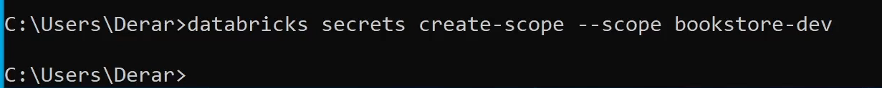

* Let us put a secret into this scope. A secret is a key-value pair representing sensitive information such as passwords. To add a secret into our secret scope, we use the secrets put command. We specify first the secret scope name. Then we provide our key-value pair. Here, the **key** is called **db_password** and the **value** is a string from **1 to 5**.



* To list secrets in a given scope, we use the **secret list** command. Here we see that there is indeed a secret with the **key** **db_password**.

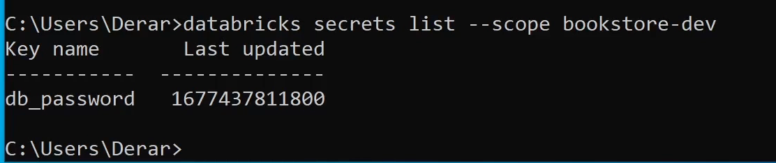

* Let us switch to Databricks platform to see how to read this value in a notebook. To read the secret value in a notebook. We need to use the **dbutils secrets** utility. As you can see, it provides the **get()** function to read the secret value in a given secret scope.

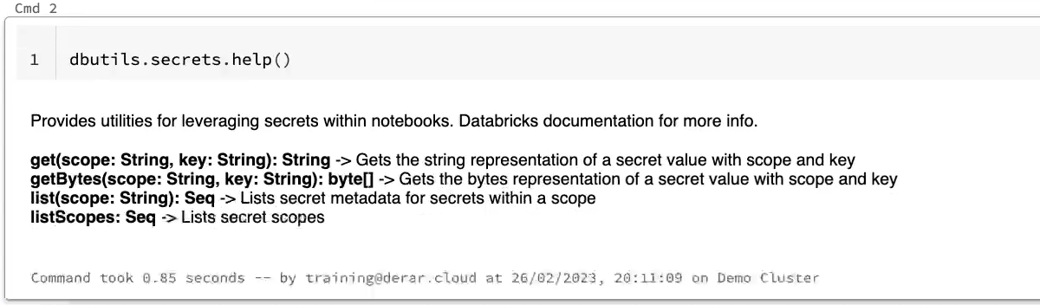

* Let us try it out. But before running this, you may wondering, as a Databricks administrator, do I have the permission to read this secret? The answer is yes. Databricks administrators have the **MANAGE permission** on all secret scopes in the workspace. This permission allows them to manage, write and read secrets. Let us run this command now.

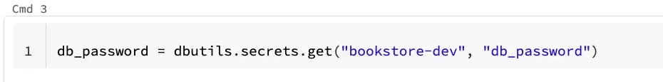

* It works without any error. It means that we managed to read the value of this secret. From now on, we can start using this password in our code.
* However, you will not be able to directly print the value. Let us try this. As you can see, the value is redacted. Databricks redacts secrets values to prevent you from accidentally printing them in a cell output. 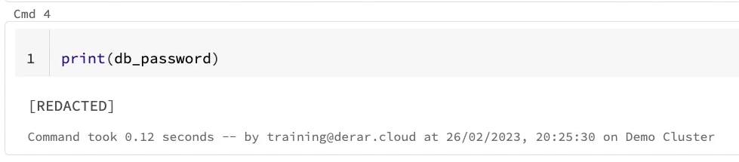
* As you can see, Databricks Secrets is really powerful.
* Instead of directly entering your credentials in a notebook, you can use Databricks secrets to store your credentials and reference them here in notebooks.